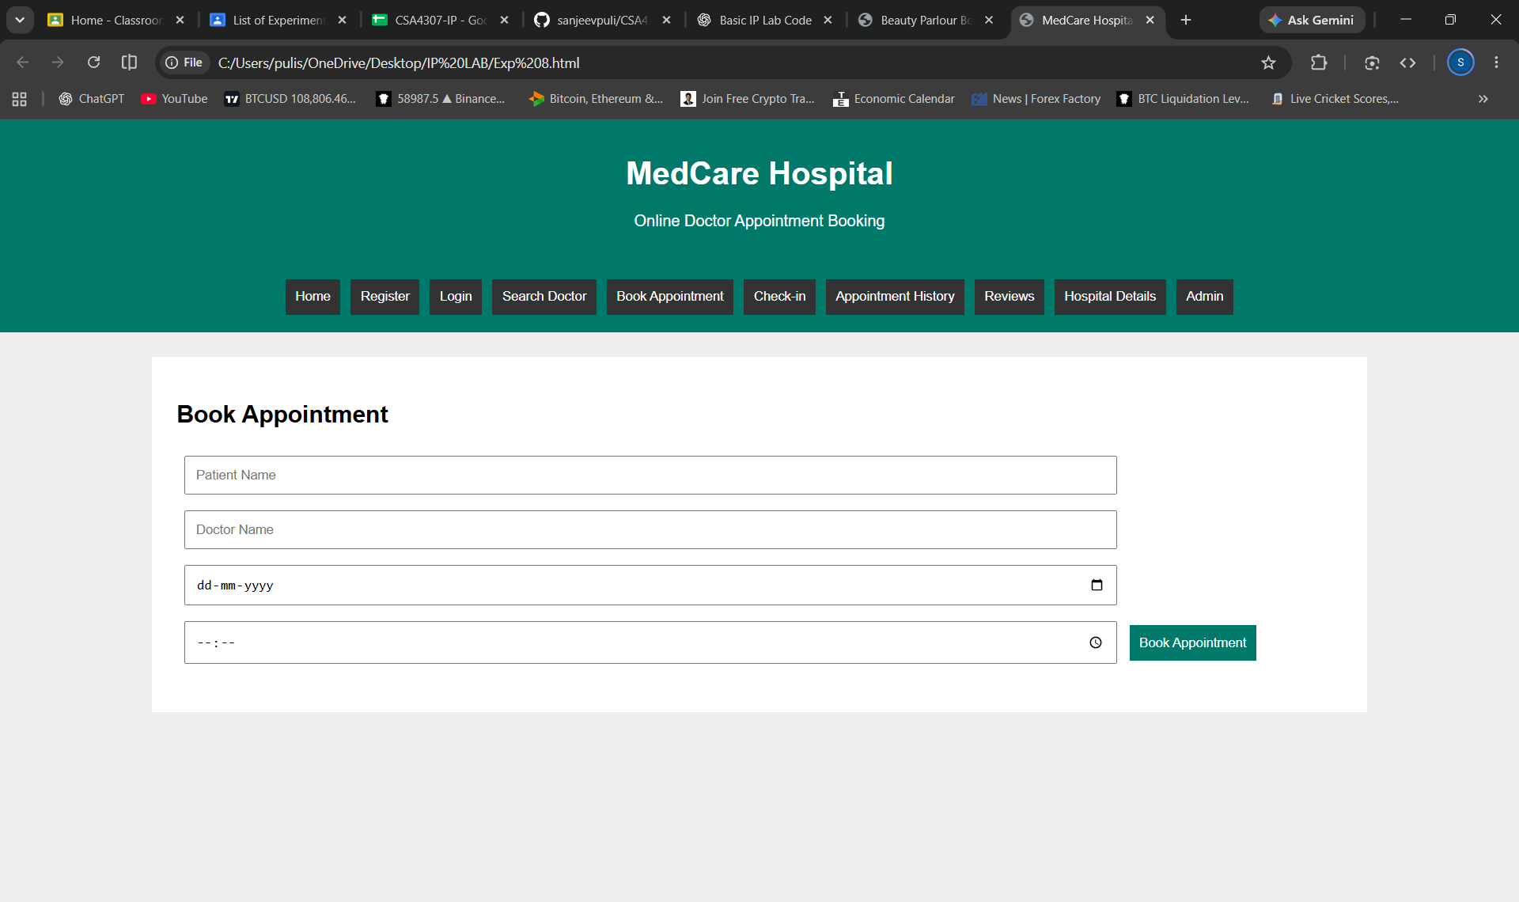
<!DOCTYPE html>
<html>
<head>
<title>MedCare Hospital</title>
<style>
body{font-family:Arial;margin:0;background:#eee}
header,nav{background:#00796b;color:white;text-align:center;padding:15px}
nav button{background:#333;color:white;border:0;padding:10px;margin:3px;cursor:pointer}
.box{background:white;margin:25px auto;padding:25px;width:80%;box-sizing:border-box}
input,select,textarea{padding:10px;margin:8px;width:80%;box-sizing:border-box}
button{padding:10px;background:#00796b;color:white;border:0;cursor:pointer}
.page{display:none}
#home{display:block}
</style>
</head>
<body>

<header>
<h1>MedCare Hospital</h1>
<p>Online Doctor Appointment Booking</p>
</header>

<nav>
<button onclick="show('home')">Home</button>
<button onclick="show('register')">Register</button>
<button onclick="show('login')">Login</button>
<button onclick="show('search')">Search Doctor</button>
<button onclick="show('booking')">Book Appointment</button>
<button onclick="show('checkin')">Check-in</button>
<button onclick="show('history')">Appointment History</button>
<button onclick="show('review')">Reviews</button>
<button onclick="show('hospital')">Hospital Details</button>
<button onclick="show('admin')">Admin</button>
</nav>

<div class="box page" id="home">
<h2>Welcome to MedCare Hospital</h2>
<p>Find doctors and book appointments easily online.</p>
</div>

<div class="box page" id="register">
<h2>Patient Registration</h2>
<input placeholder="Full Name">
<input type="email" placeholder="Email">
<input type="password" placeholder="Password">
<button onclick="alert('Registration successful')">Register</button>
</div>

<div class="box page" id="login">
<h2>Patient Login</h2>
<input placeholder="Username">
<input type="password" placeholder="Password">
<button onclick="alert('Login successful')">Login</button>
</div>

<div class="box page" id="search">
<h2>Search Doctors</h2>
<input id="location" placeholder="Enter Location">
<select id="specialty">
<option>General Physician</option>
<option>Cardiologist</option>
<option>Dentist</option>
<option>Dermatologist</option>
<option>Orthopedic</option>
</select>
<button onclick="searchDoctor()">Search</button>
<p id="searchResult"></p>
</div>

<div class="box page" id="booking">
<h2>Book Appointment</h2>
<input id="patient" placeholder="Patient Name">
<input id="doctor" placeholder="Doctor Name">
<input type="date" id="date">
<input type="time" id="time">
<button onclick="bookAppointment()">Book Appointment</button>
<p id="bookingResult"></p>
</div>

<div class="box page" id="checkin">
<h2>Patient Check-in Form</h2>
<input id="checkName" placeholder="Patient Name">
<input id="symptoms" placeholder="Reason for Visit">
<button onclick="checkin()">Submit Check-in</button>
<p id="checkResult"></p>
</div>

<div class="box page" id="history">
<h2>Appointment History</h2>
<p id="historyResult">No appointments found.</p>
<button onclick="cancelAppointment()">Cancel Appointment</button>
</div>

<div class="box page" id="review">
<h2>Doctor Review</h2>
<input id="reviewDoctor" placeholder="Doctor Name">
<select id="rating">
<option>5 Stars</option>
<option>4 Stars</option>
<option>3 Stars</option>
<option>2 Stars</option>
<option>1 Star</option>
</select>
<textarea id="comment" placeholder="Write your review"></textarea>
<button onclick="submitReview()">Submit Review</button>
<p id="reviewResult"></p>
</div>

<div class="box page" id="hospital">
<h2>Hospital Details</h2>
<input id="hospitalName" placeholder="Hospital Name">
<input id="hospitalLocation" placeholder="Hospital Location">
<button onclick="hospitalDetails()">Save Details</button>
<button onclick="window.open('https://maps.google.com','_blank')">View Google Maps</button>
<p id="hospitalResult"></p>
</div>

<div class="box page" id="admin">
<h2>Admin Panel</h2>
<input id="doctorName" placeholder="Doctor Name">
<input id="doctorSpecialty" placeholder="Specialty">
<button onclick="addDoctor()">Add Doctor</button>
<h3>Appointment Statistics</h3>
<p id="adminResult">Total Appointments: 0</p>
</div>

<script>
let appointment="";
let count=0;

function show(id){
document.querySelectorAll('.page').forEach(p=>p.style.display='none');
document.getElementById(id).style.display='block';
}

function searchDoctor(){
let l=document.getElementById('location').value;
let s=document.getElementById('specialty').value;
document.getElementById('searchResult').innerText=
'Specialty: '+s+' | Location: '+(l||'All Locations')+
' | Available Doctor: Dr. Kumar';
}

function bookAppointment(){
let p=document.getElementById('patient').value;
let d=document.getElementById('doctor').value;
let date=document.getElementById('date').value;
let time=document.getElementById('time').value;

if(!p||!d||!date||!time){
alert('Enter all appointment details');
return;
}

appointment='Patient: '+p+' | Doctor: '+d+
' | Date: '+date+' | Time: '+time;
count++;

document.getElementById('bookingResult').innerText='Appointment booked successfully!';
document.getElementById('historyResult').innerText=appointment+' | Status: Booked';
document.getElementById('adminResult').innerText='Total Appointments: '+count;
}

function checkin(){
let n=document.getElementById('checkName').value;
let s=document.getElementById('symptoms').value;
document.getElementById('checkResult').innerText=
n&&s?'Check-in submitted successfully':'Enter all details';
}

function cancelAppointment(){
if(appointment){
appointment='';
count=Math.max(0,count-1);
document.getElementById('historyResult').innerText='Appointment cancelled.';
document.getElementById('adminResult').innerText='Total Appointments: '+count;
}else{
document.getElementById('historyResult').innerText='No appointment to cancel.';
}
}

function submitReview(){
let d=document.getElementById('reviewDoctor').value;
let r=document.getElementById('rating').value;
let c=document.getElementById('comment').value;
document.getElementById('reviewResult').innerText=
d&&c?'Review submitted for '+d+' | Rating: '+r:'Enter doctor name and review';
}

function hospitalDetails(){
let n=document.getElementById('hospitalName').value;
let l=document.getElementById('hospitalLocation').value;
document.getElementById('hospitalResult').innerText=
n&&l?'Hospital: '+n+' | Location: '+l:'Enter hospital details';
}

function addDoctor(){
let n=document.getElementById('doctorName').value;
let s=document.getElementById('doctorSpecialty').value;
document.getElementById('adminResult').innerText=
n&&s?'Doctor Added: '+n+' | Specialty: '+s+' | Appointments: '+count:'Enter doctor details';
}
</script>

</body>
</html>

